Lab 3: Factors and regression — Solutions
  - F71RA Machine Learning for Risk and Insurance 1
Yubo Rasmussen
Table of contents

Before you start
This lab has three parts. Part 1 covers factors, R’s data type for categorical variables, using the forcats package. Part 2 revisits linear regression on a small data set, with a focus on reading the output critically and checking the model’s assumptions. Part 3 brings both together on the French MTPL data from Lab 2, where we will see why linear regression is the wrong tool for claim counts, fit our first Poisson GLM, and find out that even the “right” model can rest on an assumption the data do not support.
Learning objectives. By the end of this lab you should be able to
- create factors with a chosen level order, and use forcats to lump, reorder and relevel them;
- interpret the coefficients, standard errors and significance codes of a fitted lm(), and explain why a predictor can matter on its own but not in a multiple regression;
- use residual plots, QQ plots and $R^{2}$ to judge a fitted model;
- fit a Poisson GLM with an exposure offset in gamlss, interpret its coefficients as multiplicative effects, and compare models on held-out data.
Packages. Install anything missing with install.packages(). We load gamlss before the tidyverse on purpose: gamlss attaches the MASS package, which has its own select() function. Loading the tidyverse second means select() refers to dplyr::select(), which is the one we want.
library(gamlss)
library(tidyverse) # loads dplyr, ggplot2, forcats, readr and others

Part 1: Factors

Why factors?
Here is a vector of month abbreviations that we would like to put in calendar order:
x1 <- c("Dec", "Apr", "Jan", "Mar")
sort(x1)
[1] "Apr" "Dec" "Jan" "Mar"
sort() orders character strings alphabetically, which is not what we want. The fix is to tell R that these values come from a fixed, ordered set of categories, by turning the vector into a factor with the levels in the order we want.
month_levels <- c("Jan", "Feb", "Mar", "Apr", "May", "Jun",
"Jul", "Aug", "Sep", "Oct", "Nov", "Dec")
y1 <- factor(x1, levels = month_levels)
y1
[1] Dec Apr Jan Mar
Levels: Jan Feb Mar Apr May Jun Jul Aug Sep Oct Nov Dec
sort(y1)
[1] Jan Mar Apr Dec
Levels: Jan Feb Mar Apr May Jun Jul Aug Sep Oct Nov Dec
levels(y1)
[1] "Jan" "Feb" "Mar" "Apr" "May" "Jun" "Jul" "Aug" "Sep" "Oct" "Nov" "Dec"
Q1. Suppose one entry is mistyped as "Jam". What does factor() do with it? Now try forcats::fct() instead. Which behaviour would you prefer when cleaning a large insurance data set, and why?
x2 <- c("Dec", "Apr", "Jam", "Mar")
factor(x2, levels = month_levels)
[1] Dec Apr <NA> Mar
Levels: Jan Feb Mar Apr May Jun Jul Aug Sep Oct Nov Dec
fct(x2, levels = month_levels)
Error in `fct()`:
! All values of `x` must appear in `levels` or `na`
ℹ Missing level: "Jam"
Answer. factor() silently converts any value that is not in levels to NA, so the typo disappears without warning. fct() stops with an error naming the offending value. In a data set with hundreds of thousands of rows a silent NA can easily go unnoticed and end up quietly dropped by a model fit, so the loud failure is far safer.

Working with factors: the Star Wars data
dplyr ships with a small data set, starwars, describing 87 characters. We use it to practise the main forcats functions. (You may see older code that runs attach(starwars) first. Avoid this: it puts the columns into your search path, where they can clash with other objects of the same name, and every function we use here takes the data frame explicitly anyway.)
How many characters are there of each species? count() is shorthand for group_by() followed by summarise(n = n()).
starwars %>%
filter(!is.na(species)) %>%
count(species, sort = TRUE)
# A tibble: 37 × 2
species n
<chr> <int>
1 Human 35
2 Droid 6
3 Gungan 3
4 Kaminoan 2
5 Mirialan 2
6 Twi'lek 2
7 Wookiee 2
8 Zabrak 2
9 Aleena 1
10 Besalisk 1
# ℹ 27 more rows
Most species appear only once or twice. For a summary, and later for modelling, it often makes sense to lump rare categories into a single “Other” level.
Q2. We want to keep every species that appears at least 3 times and lump the rest. Compare fct_lump(species, n = 3) with fct_lump_min(species, min = 3). What does each one do, and which matches what we asked for?
starwars %>%
filter(!is.na(species)) %>%
mutate(species = fct_lump_min(species, min = 3)) %>%
count(species, sort = TRUE)
# A tibble: 4 × 2
species n
<fct> <int>
1 Other 39
2 Human 35
3 Droid 6
4 Gungan 3
starwars %>%
filter(!is.na(species)) %>%
mutate(species = fct_lump(species, n = 3)) %>%
count(species, sort = TRUE)
# A tibble: 4 × 2
species n
<fct> <int>
1 Other 39
2 Human 35
3 Droid 6
4 Gungan 3
Answer. fct_lump_min(species, min = 3) keeps every level that occurs at least 3 times, which is what we asked for. fct_lump(species, n = 3) keeps the 3 most common levels, whatever their counts. Here the two happen to give the same result, because exactly three species (Human, Droid, Gungan) have 3 or more characters, but in general they differ: change min = 3 to min = 2 and the first version keeps several more species, while n = 3 stays the same. fct_lump_prop() (lump below a proportion) and fct_lump_n() are the other variants.
Now plot the number of characters with each eye colour:
ggplot(starwars, aes(y = eye_color)) +
geom_bar() +
labs(x = "Number of characters", y = "Eye colour")
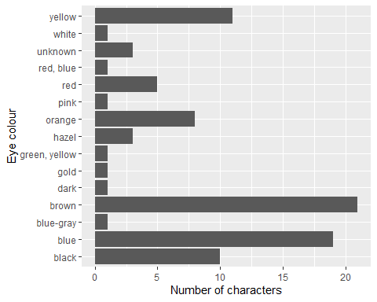
The bars are in alphabetical order, which makes the chart hard to read. fct_infreq() reorders the levels by frequency:
starwars %>%
mutate(eye_color = fct_infreq(eye_color)) %>%
ggplot(aes(y = eye_color)) +
geom_bar() +
labs(x = "Number of characters", y = "Eye colour")
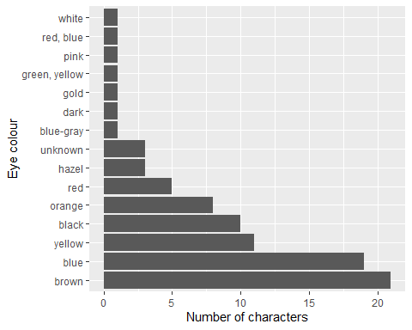
Q3. In the plot above the most common colour is at the bottom. Why? Fix it so that the most common colour is at the top.
starwars %>%
mutate(eye_color = fct_rev(fct_infreq(eye_color))) %>%
ggplot(aes(y = eye_color)) +
geom_bar() +
labs(x = "Number of characters", y = "Eye colour")
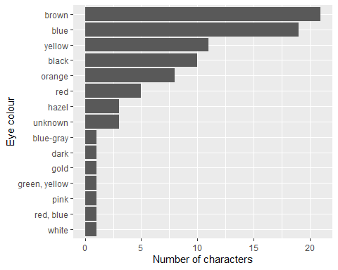
Answer. On a vertical axis ggplot2 draws the first level at the bottom, closest to the origin. fct_infreq() makes the most frequent level the first, so it ends up at the bottom. Wrapping it in fct_rev() reverses the level order.
Next, the average mass of characters by eye colour:
starwars %>%
filter(!is.na(mass)) %>%
group_by(eye_color) %>%
summarise(average_mass = mean(mass), n = n()) %>%
ggplot(aes(x = average_mass, y = eye_color)) +
geom_point() +
labs(x = "Average mass (kg)", y = "Eye colour")
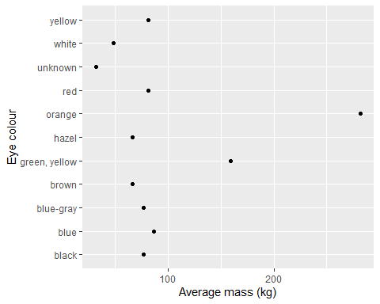
As before, the plot is easier to read if the levels are sorted, this time by the value being plotted. fct_reorder(f, x) reorders the levels of f by the values of x:
starwars %>%
filter(!is.na(mass)) %>%
group_by(eye_color) %>%
summarise(average_mass = mean(mass), n = n()) %>%
ggplot(aes(x = average_mass, y = fct_reorder(eye_color, average_mass))) +
geom_point(aes(size = n)) +
labs(x = "Average mass (kg)", y = "Eye colour", size = "Characters")
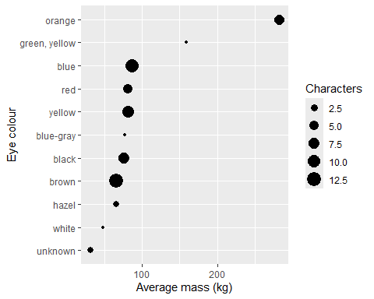
Q4. One eye colour has an average mass far above the rest. How many characters is that average based on, and which character is responsible for it? What does this have in common with the frequency tables in Lab 2?
starwars %>%
filter(!is.na(mass)) %>%
group_by(eye_color) %>%
summarise(average_mass = mean(mass), n = n()) %>%
arrange(desc(average_mass)) %>%
head(3)
# A tibble: 3 × 3
eye_color average_mass n
<chr> <dbl> <int>
1 orange 282. 6
2 green, yellow 159 1
3 blue 86.5 12
starwars %>% filter(mass > 1000) %>% select(name, eye_color, mass)
# A tibble: 1 × 3
name eye_color mass
<chr> <chr> <dbl>
1 Jabba Desilijic Tiure orange 1358
Answer. The orange-eyed group has an average mass of about 282 kg, based on 6 characters. One of them is Jabba Desilijic Tiure, at 1,358 kg; the other five average under 70 kg, in line with most other groups. The group average is really one extreme observation. This is the same issue as a claim frequency computed from very little exposure in Lab 2: a summary statistic for a small group can be dominated by one value. Showing the group size (here through the point size) is a simple guard against over-reading it.

Factors in regression: the reference level
When a factor enters a regression, R creates one dummy variable per level except the first, which becomes the reference level. Every other level’s coefficient is a difference relative to it. By default the reference is simply the first level alphabetically, which is rarely a meaningful choice. A common actuarial convention is to use the level with the most data as the reference, so that the other coefficients are measured against a well-estimated baseline.
Q5. In mtcars, cyl takes the values 4, 6 and 8. Fit lm(mpg ~ factor(cyl)), then refit it with 8 cylinders as the reference level using fct_relevel(). Explain how the coefficients change and what stays the same.
coef(lm(mpg ~ factor(cyl), data = mtcars))
(Intercept) factor(cyl)6 factor(cyl)8
26.663636 -6.920779 -11.563636
mtcars_rl <- mtcars %>% mutate(cyl = fct_relevel(factor(cyl), "8"))
coef(lm(mpg ~ cyl, data = mtcars_rl))
(Intercept) cyl4 cyl6
15.100000 11.563636 4.642857
Answer. In the first fit the intercept, 26.66, is the mean mpg of 4-cylinder cars, and the other two coefficients are the differences for 6 cylinders ($−6.92$) and 8 cylinders ($−11.56$). With 8 as the reference the intercept becomes the mean for 8-cylinder cars (15.10) and the coefficients are now the differences for 4 cylinders ($+11.56$) and 6 cylinders ($+4.64$). The fitted values and the fit itself are identical; only the parametrisation changes. The group means can be recovered from either version.

Part 2: Linear regression

The model
Linear regression predicts a response $Y$ from $p$ explanatory variables $x_{1},…,x_{p}$. For observations $i=1,…,n$ the model is
$$Y_{i}=β_{0}+β_{1}x_{i1}+β_{2}x_{i2}+⋯+β_{p}x_{ip}+ε_{i}, ε_{i}\overset{\text{iid}}{∼}N(0,σ^{2}).$$
In matrix form, $Y=Xβ+ε$, and the least-squares estimate is $\hat{β}=(X^{⊤}X)^{−1}X^{⊤}Y$, which you computed by hand at the end of Lab 1. In R the model is fitted with lm().
We use the built-in mtcars data (type ?mtcars for a description) and model fuel efficiency, mpg (miles per US gallon), using
- cyl, number of cylinders,
- hp, gross horsepower,
- wt, weight in thousands of pounds.
head(mtcars)
mpg cyl disp hp drat wt qsec vs am gear carb
Mazda RX4 21.0 6 160 110 3.90 2.620 16.46 0 1 4 4
Mazda RX4 Wag 21.0 6 160 110 3.90 2.875 17.02 0 1 4 4
Datsun 710 22.8 4 108 93 3.85 2.320 18.61 1 1 4 1
Hornet 4 Drive 21.4 6 258 110 3.08 3.215 19.44 1 0 3 1
Hornet Sportabout 18.7 8 360 175 3.15 3.440 17.02 0 0 3 2
Valiant 18.1 6 225 105 2.76 3.460 20.22 1 0 3 1
LM <- lm(mpg ~ cyl + hp + wt, data = mtcars)
summary(LM)
Call:
lm(formula = mpg ~ cyl + hp + wt, data = mtcars)
Residuals:
Min 1Q Median 3Q Max
-3.9290 -1.5598 -0.5311 1.1850 5.8986
Coefficients:
Estimate Std. Error t value Pr(>|t|)
(Intercept) 38.75179 1.78686 21.687 < 2e-16 ***
cyl -0.94162 0.55092 -1.709 0.098480 .
hp -0.01804 0.01188 -1.519 0.140015
wt -3.16697 0.74058 -4.276 0.000199 ***
---
Signif. codes: 0 '***' 0.001 '**' 0.01 '*' 0.05 '.' 0.1 ' ' 1
Residual standard error: 2.512 on 28 degrees of freedom
Multiple R-squared: 0.8431, Adjusted R-squared: 0.8263
F-statistic: 50.17 on 3 and 28 DF, p-value: 2.184e-11
The fitted model is
$$\hat{\text{mpg}}=38.75−0.942 \text{cyl}−0.0180 \text{hp}−3.17 \text{wt}.$$
Q6. Interpret the coefficient on wt in plain language. Then say what the Std. Error, t value and Pr(>|t|) columns, and the significance codes, tell you about each coefficient.
Answer. Holding the number of cylinders and horsepower fixed, each additional 1,000 lb of weight is associated with a fall of about 3.2 mpg. The standard error measures how precisely each coefficient is estimated; the t value is the estimate divided by its standard error; and Pr(>|t|) is the p-value for testing whether that coefficient is zero given the other variables are in the model. The significance codes summarise the p-values: *** means $p<0.001$, . means $0.05≤p<0.1$ and a blank means $p≥0.1$. Here weight is strongly significant ($p=0.0002$), cylinders is only marginal ($p=0.098$), and horsepower is not significant at conventional levels ($p=0.14$).
Q7. Now fit mpg ~ cyl on its own. Is cyl significant? How can it be highly significant here but not in the model above? Hint: look at cor(mtcars[, c("cyl", "hp", "wt")]).
summary(lm(mpg ~ cyl, data = mtcars))$coefficients
Estimate Std. Error t value Pr(>|t|)
(Intercept) 37.88458 2.0738436 18.267808 8.369155e-18
cyl -2.87579 0.3224089 -8.919699 6.112687e-10
cor(mtcars[, c("cyl", "hp", "wt")])
cyl hp wt
cyl 1.0000000 0.8324475 0.7824958
hp 0.8324475 1.0000000 0.6587479
wt 0.7824958 0.6587479 1.0000000
Answer. On its own cyl is extremely significant: each extra cylinder is associated with about 2.9 fewer mpg ($p≈6×{10}^{−10}$). But cyl is strongly correlated with both hp (0.83) and wt (0.78): cars with more cylinders also tend to be heavier and more powerful. Once weight is in the model, there is little additional information left in the number of cylinders, so its coefficient shrinks and its standard error grows. This is multicollinearity. It does not mean cylinders are unrelated to fuel use; it means the data cannot separate the effects of three variables that move together. The p-value in a multiple regression always answers the question “does this variable help given the others?”.
Q8. Copy the summary(LM) output into ChatGPT (or another AI assistant) and ask it to interpret the results. One such tool gave this summary:
“Heavier cars with more cylinders and higher horsepower generally use more fuel. But in this model, weight is the key factor driving mpg differences.”
Do you agree? Identify anything that is overstated or that the model cannot support.
Answer. The signs are right and the second sentence is a fair reading. But the first sentence presents all three as established effects, whereas in this model only weight is statistically significant at the 5% level; the data do not let us say that cylinders or horsepower affect mpg once weight is accounted for. “Driving” also suggests causation, which an observational regression on 32 cars cannot establish: weight is the variable most strongly associated with mpg after adjusting for the others. A fair summary would be: “mpg falls with weight, about 3.2 mpg per 1,000 lb; cylinders and horsepower are also negatively associated with mpg, but because they are strongly correlated with weight their separate effects are not precisely estimated.” The general lesson is that AI summaries of regression output tend to be fluent and plausible, and need checking against the numbers.

Residuals
The residuals $e_{i}=y_{i}−{\hat{y}}_{i}$ are our estimates of the errors $ε_{i}$. If the model is adequate they should look like independent draws from $N(0,σ^{2})$: centred on zero, with constant spread, and with no pattern when plotted against the fitted values. residuals() extracts them; fitted() extracts ${\hat{y}}_{i}$.
res <- residuals(LM)
summary(res)
Min. 1st Qu. Median Mean 3rd Qu. Max.
-3.9290 -1.5598 -0.5311 0.0000 1.1850 5.8986
par(mfrow = c(1, 2))
plot(fitted(LM), res, xlab = "Fitted values", ylab = "Residuals",
main = "Residuals vs fitted")
abline(h = 0, col = "red", lty = 2)
qqnorm(res, main = "Normal QQ plot of residuals")
qqline(res, col = "red", lty = 2)
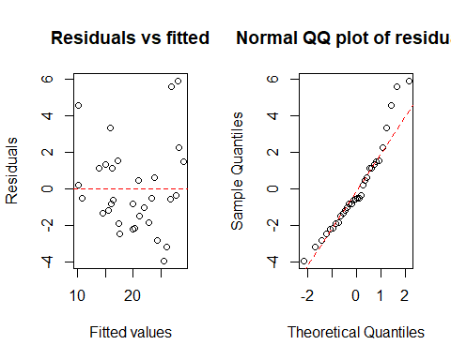
par(mfrow = c(1, 1))
The QQ plot compares the sorted residuals with the quantiles you would expect from a normal sample of the same size. If the residuals are normal the points lie close to the straight line; curvature at the ends indicates skewness or heavy tails. (R’s built-in plot(LM) produces these and two further diagnostic plots in one call.)
Q9. Is there any pattern in the residuals-versus-fitted plot? Do the residuals look normal? How much weight would you put on these conclusions with $n=32$?
Answer. There is a mild U-shape: residuals tend to be positive for the lowest and highest fitted values and negative in the middle, which suggests the relationship with mpg is somewhat curved (fuel efficiency is closer to linear in $1/\text{weight}$ than in weight). The QQ plot is reasonably straight, with a few large positive residuals in the upper tail (the Toyota Corolla and Fiat 128 are noticeably more efficient than the model predicts). With only 32 points both plots are noisy, so neither suggests a serious problem, but the curvature is worth following up, for example by adding I(wt^2) or modelling log(mpg).

Goodness of fit
$R^{2}$ is the proportion of the variability in $Y$ explained by the model; adjusted $R^{2}$, ${\overset{‾}{R}}^{2}$, adds a penalty for the number of predictors $p$:
R2=1−i​(yi−yi)2i​(yi−y)2, R2=1−(1−R2) n−1n−p−1.
Q10. Compute $R^{2}$ and ${\overset{‾}{R}}^{2}$ for LM from the formulas and check them against summary(LM). Then add a column of pure noise, noise = rnorm(32), to the model. What happens to each?
y <- mtcars$mpg
n <- nrow(mtcars); p <- 3
R2 <- 1 - sum(residuals(LM)^2) / sum((y - mean(y))^2)
R2_adj <- 1 - (1 - R2) * (n - 1) / (n - p - 1)
c(R2 = R2, R2_adj = R2_adj)
R2 R2_adj
0.8431500 0.8263446
c(summary(LM)$r.squared, summary(LM)$adj.r.squared)
[1] 0.8431500 0.8263446
set.seed(3)
mtcars_noise <- mtcars %>% mutate(noise = rnorm(n()))
LM_noise <- lm(mpg ~ cyl + hp + wt + noise, data = mtcars_noise)
c(R2 = summary(LM_noise)$r.squared, R2_adj = summary(LM_noise)$adj.r.squared)
R2 R2_adj
0.8434518 0.8202595
Answer. The hand calculation matches summary(): $R^{2}=0.843$, ${\overset{‾}{R}}^{2}=0.826$. Adding a predictor that is pure noise still increases $R^{2}$ slightly, because least squares can always use an extra column to fit the sample a little better, even by chance. Adjusted $R^{2}$ falls, because the penalty for the extra parameter outweighs the tiny gain. This is why $R^{2}$ alone should never be used to decide whether to add a variable. Adjusted $R^{2}$ is a crude improvement; in later labs we will use information criteria (AIC, BIC) and, above all, performance on held-out data.

Part 3: Case study — modelling claim counts
We return to the French MTPL data from Lab 2. The response is now ClaimNb, the number of claims on each policy. Make sure freMTPL2freq.csv (from the course GitHub page) is in the same folder as this notebook.

Task 1: Load and prepare the data
Load the data and apply the same caps as in Lab 2 (ClaimNb at 4, Exposure at 1). Then convert Area, VehPower, VehGas, VehBrand and Region to factors. Following the convention from Part 1, use fct_infreq() so that each factor’s reference level is its most common level. Check the reference levels.
dat <- read_csv("freMTPL2freq.csv") %>%
mutate(ClaimNb = pmin(ClaimNb, 4),
Exposure = pmin(Exposure, 1),
across(c(Area, VehPower, VehGas, VehBrand, Region),
~ fct_infreq(factor(.x))))
sapply(dat[c("Area", "VehPower", "VehGas", "VehBrand", "Region")],
function(f) levels(f)[1])
Area VehPower VehGas VehBrand Region
"C" "6" "Regular" "B12" "R24"
Answer. The reference levels are Area C, vehicle power 6, Regular fuel, brand B12 and region R24 (the Centre region), each the most common level of its factor. We treat VehPower as a factor because Lab 2 showed its relationship with claim frequency is not monotone. Density will enter the models on the log scale, as in Lab 2, because it ranges over four orders of magnitude.

Task 2: A linear regression for claim counts
Fit a linear regression of ClaimNb on all the rating factors, with log(Density) in place of Density. Look at $R^{2}$, then answer:
- How many policies have a negative fitted number of claims?
- Does the model take account of Exposure? Should it?
form <- ClaimNb ~ Area + VehPower + VehGas + VehBrand + Region +
log(Density) + VehAge + DrivAge + BonusMalus
model1 <- lm(form, data = dat)
summary(model1)$r.squared
[1] 0.006803227
sum(fitted(model1) < 0)
[1] 916
min(fitted(model1))
[1] -0.1106967
Answer. $R^{2}$ is about 0.007: the model explains less than 1% of the variation in claim counts. That is not in itself a sign of failure, since whether an individual policy has a claim in a given year is mostly luck and no model can predict it well. But two features of the fit are plainly wrong. First, 916 policies have a negative fitted number of claims (the smallest is $−0.11$), which is impossible. Second, the model ignores Exposure entirely: a policy observed for one month is predicted to have the same number of claims as an otherwise identical policy observed for a year. We could add Exposure as another predictor, but a linear model would then add a fixed amount for each unit of exposure regardless of how risky the policy is, which is the wrong structure.

Task 3: Residual analysis for the linear model
Plot the residuals against the fitted values, a histogram of the residuals and a normal QQ plot. Use pch = "." in plot() to keep the scatter plot readable with 678,000 points. Explain what you see.
res1 <- residuals(model1)
summary(res1)
Min. 1st Qu. Median Mean 3rd Qu. Max.
-0.28831 -0.06334 -0.05003 0.00000 -0.03752 3.97406
par(mfrow = c(1, 3))
plot(fitted(model1), res1, pch = ".", xlab = "Fitted values", ylab = "Residuals",
main = "Residuals vs fitted")
abline(h = 0, col = "red", lty = 2)
hist(res1, breaks = 50, main = "Histogram of residuals", xlab = "Residuals")
qqnorm(res1, pch = ".", main = "Normal QQ plot")
qqline(res1, col = "red", lty = 2)
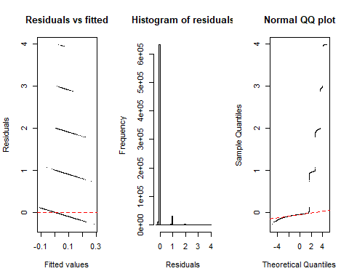
par(mfrow = c(1, 1))
Answer. All three plots show that the normal-error assumption fails badly.
- The residuals-versus-fitted plot consists of parallel diagonal bands, one for each possible value of ClaimNb (0, 1, 2, 3, 4). Because $y_{i}$ can only take a few values, $e_{i}=y_{i}−{\hat{y}}_{i}$ falls on lines of slope $−1$. The spread is far from constant.
- The histogram is dominated by a spike just below zero (the 95% of policies with no claims, whose residuals are $−{\hat{y}}_{i}$) and a long right tail; the median residual is $−0.05$ while the maximum is about 4.
- The QQ plot is nothing like a straight line: a flat section for the zero-claim policies and a step for each higher claim count.
None of this is surprising. Claim counts are small non-negative integers, mostly zero; a normal distribution is a poor description of them however good the mean model is.

Task 4: A Poisson GLM
A natural model for claim counts is the Poisson regression:
$$N_{i}∼\text{Poisson}(μ_{i}), logμ_{i}=log({\text{Exposure}}_{i})+β_{0}+β_{1}x_{i1}+⋯+β_{p}x_{ip}.$$
The log link guarantees $μ_{i}>0$, and the term $log({\text{Exposure}}_{i})$, which has its coefficient fixed at 1, is the offset from Lab 2, Task 3. It makes the expected number of claims proportional to exposure: $μ_{i}={\text{Exposure}}_{i}×λ(x_{i})$, where $λ(x_{i})=exp(β_{0}+β^{⊤}x_{i})$ is the annual claim frequency.
Fit this model with gamlss(..., family = PO) on a random 10% of the data, keeping the other 90% aside as a test set for Task 6. Use set.seed(2026) so your split matches the solutions. Print the coefficients with summary(model2, type = "qr"), which is much faster than the default for a model of this size.
set.seed(2026)
train_idx <- sample(nrow(dat), size = round(0.1 * nrow(dat)))
train <- dat[train_idx, ]
test <- dat[-train_idx, ]
model2 <- gamlss(update(form, . ~ . + offset(log(Exposure))),
family = PO, data = train, trace = FALSE)
summary(model2, type = "qr")
******************************************************************
Family: c("PO", "Poisson")
Call: gamlss(formula = update(form, . ~ . + offset(log(Exposure))),
family = PO, data = train, trace = FALSE)
Fitting method: RS()
------------------------------------------------------------------
Mu link function: log
Mu Coefficients:
Estimate Std. Error z value Pr(>|z|)
(Intercept) -3.5977264 0.2460754 -14.620 < 2e-16 ***
AreaD 0.0508695 0.0749656 0.679 0.497410
AreaE -0.0488702 0.1236509 -0.395 0.692675
AreaA 0.0312255 0.1039919 0.300 0.763973
AreaB 0.0724442 0.0747988 0.969 0.332784
AreaF -0.2365474 0.2093939 -1.130 0.258612
VehPower7 -0.1412199 0.0502717 -2.809 0.004968 **
VehPower5 -0.1411427 0.0514473 -2.743 0.006080 **
VehPower4 -0.2219732 0.0560488 -3.960 7.48e-05 ***
VehPower8 -0.2443341 0.0792190 -3.084 0.002040 **
VehPower10 0.0862805 0.0813151 1.061 0.288661
VehPower9 0.0749633 0.0822343 0.912 0.361989
VehPower11 -0.2333855 0.1200109 -1.945 0.051811 .
VehPower12 -0.4967039 0.1884526 -2.636 0.008396 **
VehPower13 -0.4471995 0.2961794 -1.510 0.131071
VehPower15 -0.2871053 0.2928333 -0.980 0.326869
VehPower14 -0.8477125 0.4116751 -2.059 0.039477 *
VehGasDiesel -0.0841794 0.0359575 -2.341 0.019228 *
VehBrandB1 -0.2779161 0.0559713 -4.965 6.86e-07 ***
VehBrandB2 -0.2824140 0.0559195 -5.050 4.41e-07 ***
VehBrandB3 -0.1802684 0.0714020 -2.525 0.011580 *
VehBrandB5 -0.1171629 0.0805888 -1.454 0.145992
VehBrandB6 -0.1712286 0.0874334 -1.958 0.050184 .
VehBrandB4 -0.3808059 0.0994852 -3.828 0.000129 ***
VehBrandB10 -0.1793898 0.1170994 -1.532 0.125536
VehBrandB11 -0.1010284 0.1282948 -0.787 0.431007
VehBrandB13 -0.3352134 0.1389713 -2.412 0.015861 *
VehBrandB14 -0.4168348 0.2619705 -1.591 0.111575
RegionR82 0.0182755 0.0588757 0.310 0.756251
RegionR93 -0.0807749 0.0660099 -1.224 0.221073
RegionR11 -0.0076559 0.0759835 -0.101 0.919743
RegionR53 0.0455262 0.0691877 0.658 0.510532
RegionR52 -0.1238978 0.0793853 -1.561 0.118591
RegionR91 -0.1744444 0.0915491 -1.905 0.056719 .
RegionR72 -0.1426629 0.0911287 -1.566 0.117463
RegionR31 -0.1849993 0.0996749 -1.856 0.063450 .
RegionR54 -0.0167827 0.1021095 -0.164 0.869448
RegionR73 -0.2324102 0.1298116 -1.790 0.073395 .
RegionR41 -0.3425187 0.1364039 -2.511 0.012037 *
RegionR25 0.0713440 0.1228922 0.581 0.561549
RegionR26 -0.0004747 0.1420815 -0.003 0.997334
RegionR23 -0.0757648 0.1833198 -0.413 0.679392
RegionR22 -0.1486594 0.1670329 -0.890 0.373466
RegionR83 -0.7526379 0.2916624 -2.581 0.009865 **
RegionR74 0.0406723 0.1997805 0.204 0.838678
RegionR94 0.0993959 0.1946562 0.511 0.609615
RegionR21 -0.2849324 0.3045602 -0.936 0.349503
RegionR42 -0.3652475 0.3562224 -1.025 0.305205
RegionR43 -0.9967715 0.7081838 -1.408 0.159278
log(Density) 0.0444423 0.0395877 1.123 0.261595
VehAge -0.0361169 0.0036757 -9.826 < 2e-16 ***
DrivAge 0.0059833 0.0012488 4.791 1.66e-06 ***
BonusMalus 0.0234427 0.0009765 24.006 < 2e-16 ***
---
Signif. codes: 0 '***' 0.001 '**' 0.01 '*' 0.05 '.' 0.1 ' ' 1
------------------------------------------------------------------
No. of observations in the fit: 67801
Degrees of Freedom for the fit: 53
Residual Deg. of Freedom: 67748
at cycle: 2
Global Deviance: 28817.25
AIC: 28923.25
SBC: 29406.84
******************************************************************
Q11. Coefficients in a log-link model act multiplicatively: increasing $x_{j}$ by one unit multiplies the expected frequency by $e^{β_{j}}$. Compute $e^{\hat{β}}$ for BonusMalus, VehAge and DrivAge, and interpret each in words.
round(exp(coef(model2)[c("BonusMalus", "VehAge", "DrivAge")]), 4)
BonusMalus VehAge DrivAge
1.0237 0.9645 1.0060
Answer. Each additional point of bonus–malus multiplies the expected claim frequency by about 1.024, a 2.4% increase per point, so a policyholder at 100 has roughly ${1.024}^{50}≈3.2$ times the frequency of one at 50 with otherwise identical characteristics. Each extra year of vehicle age multiplies the frequency by about 0.964, a 3.6% decrease per year. Each extra year of driver age multiplies it by about 1.006, a small increase. That last result looks at odds with Lab 2, where young drivers were by far the riskiest; the explanation is that DrivAge enters linearly on the log scale, which cannot capture a steep fall at young ages followed by a flat stretch, and that BonusMalus already absorbs much of the young-driver effect, since new drivers start above the base level. The stretch exercise explores this.
It is worth knowing that gamlss with the PO family fits exactly the same model as base R’s glm(..., family = poisson). gamlss becomes essential when we also want to model the variance or other parameters of the distribution, which we will do later in the course.
model2_glm <- glm(form, offset = log(Exposure), family = poisson, data = train)
max(abs(coef(model2) - coef(model2_glm)))
[1] 6.405579e-07

Task 5: Residual analysis for the Poisson model
For a discrete response, ordinary residuals $y_{i}−{\hat{μ}}_{i}$ show the same banding we saw in Task 3 however good the model is. gamlss instead returns normalised randomised quantile residuals. For each observation, it finds where $y_{i}$ falls in its own fitted distribution, $F(y_{i};{\hat{μ}}_{i})$, adds a small random jitter to smooth over the discreteness, and maps the result through the standard normal quantile function $Φ^{−1}$. If the model is correct, these residuals are exactly standard normal, whatever the response distribution.
Produce the same plots as in Task 3 for residuals(model2) and compare.
res2 <- residuals(model2)
summary(res2)
Min. 1st Qu. Median Mean 3rd Qu. Max.
-4.514471 -0.683829 -0.011614 -0.000734 0.668418 5.999810
par(mfrow = c(1, 3))
plot(fitted(model2), res2, pch = ".", xlab = "Fitted values", ylab = "Quantile residuals",
main = "Residuals vs fitted")
abline(h = 0, col = "red", lty = 2)
hist(res2, breaks = 50, main = "Histogram of residuals", xlab = "Quantile residuals")
qqnorm(res2, pch = ".", main = "Normal QQ plot")
qqline(res2, col = "red", lty = 2)
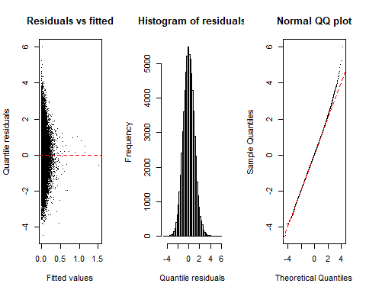
par(mfrow = c(1, 1))
Answer. The quantile residuals look very much like a standard normal sample: centred on zero (mean within about 0.01 of zero), with quartiles at about $±0.67$ (the standard normal’s are $±0.674$), a symmetric bell-shaped histogram and a QQ plot that is close to straight. There is no banding and no obvious pattern against the fitted values. On these diagnostics the Poisson model is far better than the linear one. Note that the jitter makes these residuals random: refit and replot and the points move slightly, though the overall picture does not.

Task 6: Which model predicts better?
Residual plots tell us whether a model’s assumptions look reasonable; they do not tell us directly which model makes better predictions. For that we use the test set. A natural measure for count data is the mean Poisson deviance,
$$D=\frac{2}{n}\sum_{i=1}^{n}{\left[y_{i}log\frac{y_{i}}{{\hat{μ}}_{i}}−(y_{i}−{\hat{μ}}_{i})\right]},$$
where the first term is taken as zero when $y_{i}=0$. Lower is better. It penalises predictions that are too low for policies that did claim, and it requires ${\hat{μ}}_{i}>0$, so the function below floors predictions at a small positive value to allow the linear model to be scored.
Refit the linear model on train (so both models see the same data) and compare the two on test. Include a “null” model that predicts the same number of claims, the training mean, for every policy.
poisson_deviance <- function(y, mu) {
mu <- pmax(mu, 1e-6)
2 * mean(ifelse(y == 0, 0, y * log(y / mu)) - (y - mu))
}
model1_train <- lm(form, data = train)
pred_lm <- predict(model1_train, newdata = test)
pred_pois <- predict(model2, newdata = test, type = "response", data = train)
pred_null <- rep(mean(train$ClaimNb), nrow(test))
c(null = poisson_deviance(test$ClaimNb, pred_null),
linear = poisson_deviance(test$ClaimNb, pred_lm),
poisson = poisson_deviance(test$ClaimNb, pred_pois))
null linear poisson
0.3200878 0.3161049 0.3199380
Q12. Which model has the lowest test deviance? Is that what you expected after Task 5?
Answer. Surprisingly, the linear model does slightly better (0.316) than the Poisson GLM (0.320), and the Poisson GLM barely beats the null model (0.320). This is not what the residual plots suggested. The Poisson model has the right kind of distribution and passes the residual checks, yet its predictions are no better than a model that produces negative claim counts. Something in the Poisson model must be wrong, and it is not something the quantile residuals were able to detect. Task 7 finds it.

Task 7: Investigating the surprise
The one structural assumption the Poisson model makes that the linear model does not is the offset: expected claims are proportional to exposure. Check it directly.
(a) Band Exposure into $(0,0.1]$, $(0.1,0.25]$, $(0.25,0.5]$, $(0.5,0.75]$, $(0.75,0.99]$ and $(0.99,1]$, and compute for each band the number of policies, the average number of claims per policy, and the claim frequency (claims divided by exposure). If claims were proportional to exposure, what should the frequency column look like?
dat %>%
mutate(exposure_band = cut(Exposure, c(0, 0.1, 0.25, 0.5, 0.75, 0.99, 1))) %>%
group_by(exposure_band) %>%
summarise(policies = n(),
claims_per_policy = mean(ClaimNb),
frequency = sum(ClaimNb) / sum(Exposure))
# A tibble: 6 × 4
exposure_band policies claims_per_policy frequency
<fct> <int> <dbl> <dbl>
1 (0,0.1] 127596 0.0270 0.457
2 (0.1,0.25] 95216 0.0386 0.211
3 (0.25,0.5] 131302 0.0492 0.126
4 (0.5,0.75] 92494 0.0645 0.102
5 (0.75,0.99] 62056 0.0756 0.0868
6 (0.99,1] 169349 0.0698 0.0698
(b) Instead of fixing the coefficient of $log(\text{Exposure})$ at 1, let the model estimate it: include log(Exposure) as an ordinary predictor. What is its estimated coefficient? Compare the test deviance of this model with the others.
model3 <- gamlss(update(form, . ~ . + log(Exposure)),
family = PO, data = train, trace = FALSE)
coef(model3)["log(Exposure)"]
log(Exposure)
0.3731604
pred_pois_free <- predict(model3, newdata = test, type = "response", data = train)
c(linear = poisson_deviance(test$ClaimNb, pred_lm),
poisson_offset = poisson_deviance(test$ClaimNb, pred_pois),
poisson_free = poisson_deviance(test$ClaimNb, pred_pois_free))
linear poisson_offset poisson_free
0.3161049 0.3199380 0.3079212
Answer.
(a) If expected claims were proportional to exposure, the frequency would be roughly the same in every band and claims per policy would grow in proportion to exposure. Instead, the frequency falls from 0.46 for policies observed for less than 0.1 years to 0.07 for full-year policies, a factor of more than six. Claims per policy do rise with exposure, but far more slowly than proportionally, and are actually slightly lower for full-year policies than for the $(0.75,0.99]$ band. In this data set, short exposures are associated with disproportionately many claims. Plausible explanations include policies that end early because of a claim (a car written off, for example), or a policy record being split when the contract changes mid-year; the data do not tell us which. This is the same quirk that produced the very high frequency for cars under a year old in Lab 2.
(b) The estimated coefficient on $log(\text{Exposure})$ is about 0.37 rather than 1: expected claims grow roughly like ${\text{Exposure}}^{0.37}$. With the coefficient estimated freely, the Poisson model has the lowest test deviance of all (0.308, against 0.316 for the linear model and 0.320 for the offset model). The linear model had done comparatively well simply because it never imposed proportionality in the first place.
The broader lessons:
- Residual diagnostics are necessary but not sufficient. The quantile residuals looked excellent even though a key assumption was badly wrong. With mostly zero counts, each observation carries very little information about the fit, so residual plots have little power to detect misspecification.
- Check structural assumptions directly against the data, as in (a), and compare models on held-out data, as in Task 6. It was the test-set comparison, not the residual plots, that revealed the problem.
- The offset is still the right default for most insurance data, where exposure is a genuine measure of time at risk. Here it is the data, not the method, that departs from the standard assumption, and an actuary would want to understand why before deciding how to model it.

Stretch
Lab 2 showed that claim frequency is far from linear in driver age. Replace DrivAge in model3 with the banded version from Lab 2, cut(DrivAge, c(18, 21, 26, 31, 41, 51, 71, 101), right = FALSE), refit, and compare the test deviance. Do the fitted band coefficients reproduce the pattern you saw in the Lab 2 frequency plot?
band_age <- function(d) mutate(d, DrivAge_band = cut(DrivAge, c(18, 21, 26, 31, 41, 51, 71, 101),
right = FALSE))
train <- band_age(train); test <- band_age(test)
form_band <- ClaimNb ~ Area + VehPower + VehGas + VehBrand + Region +
log(Density) + VehAge + DrivAge_band + BonusMalus + log(Exposure)
model4 <- gamlss(form_band, family = PO, data = train, trace = FALSE)
pred4 <- predict(model4, newdata = test, type = "response", data = train)
c(poisson_free = poisson_deviance(test$ClaimNb, pred_pois_free),
banded_age = poisson_deviance(test$ClaimNb, pred4))
poisson_free banded_age
0.3079212 0.3074841
round(exp(coef(model4)[grep("DrivAge_band", names(coef(model4)))]), 3)
DrivAge_band[21,26) DrivAge_band[26,31) DrivAge_band[31,41)
0.664 0.525 0.697
DrivAge_band[41,51) DrivAge_band[51,71) DrivAge_band[71,101)
0.936 0.851 1.031
Answer. Banding driver age lowers the test deviance only slightly (0.3075 against 0.3079). The fitted multipliers, relative to the reference band of 18–20, do not reproduce the Lab 2 pattern. They fall to about 0.53 for drivers aged 26–30, but then rise again: 0.94 for 41–50 and 1.03 for drivers over 70, so that older drivers come out about as risky as the youngest.
The reason is that the model also contains BonusMalus, which is strongly related to age. In the training data the average bonus–malus level falls from 96 for drivers aged 18–20 to about 53 for drivers over 50, because new drivers start with a malus and earn their bonus over years without claims. Much of what makes young drivers risky in the raw Lab 2 table is therefore already priced in through their bonus–malus level. The age coefficients measure the effect of age at a given bonus–malus level, and at a given level an older driver, who has had more years in which to earn a discount and has not, is relatively risky. This is the same lesson as Q7 with cyl and wt: a coefficient in a multiple regression answers a different question from a one-way table.
The reference band is also the youngest, which has the least data (701 training policies); relevelling DrivAge_band to its most common band with fct_infreq() would give more precisely estimated coefficients without changing the predictions.

